**BlockChain and Cryptocurrency**

Name: Aqsa Arshad

Roll no: 20L-1166

Section: 8B

**Assignment 2**

**Task 1 and 2:**

I set up a developing environment as shown below. These warnings are common while such installations.

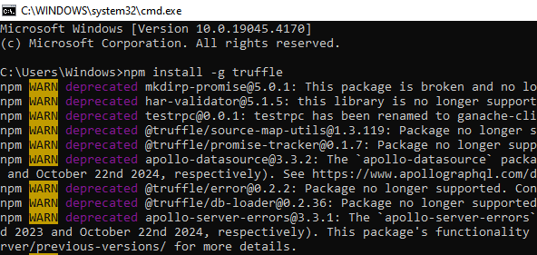

Environment is set. Then I created a truffle project named **pet-shop** using the Truffle box as shown.

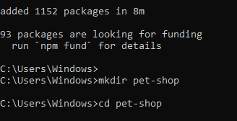

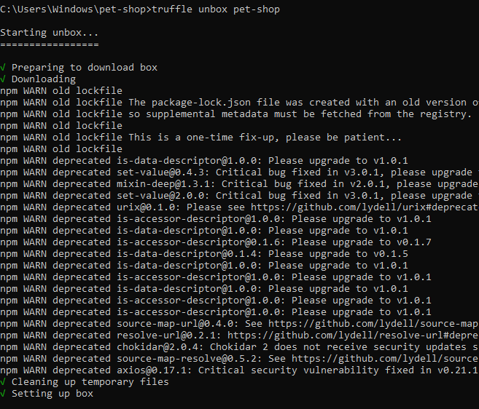

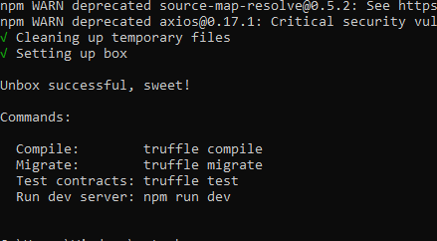

**Task 3:**

Then I wrote a smart contract in **Adaption.sol** file.

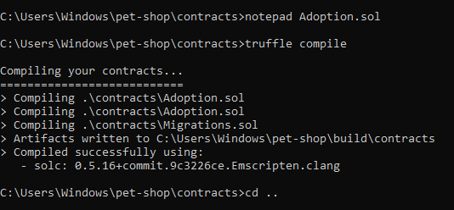

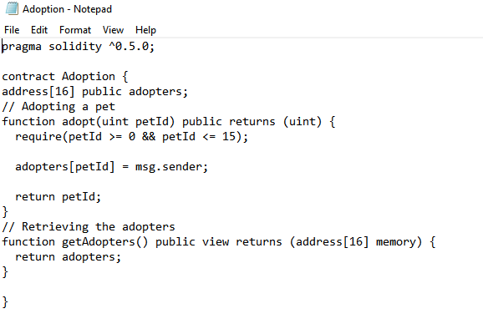

**Compilation**:

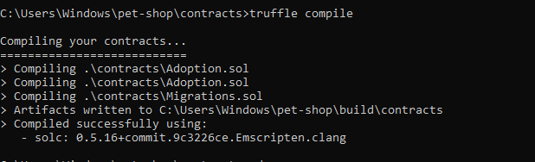

**Migration:**

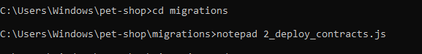

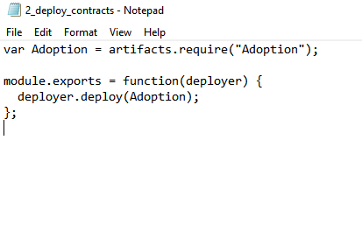

**Ganache App:**

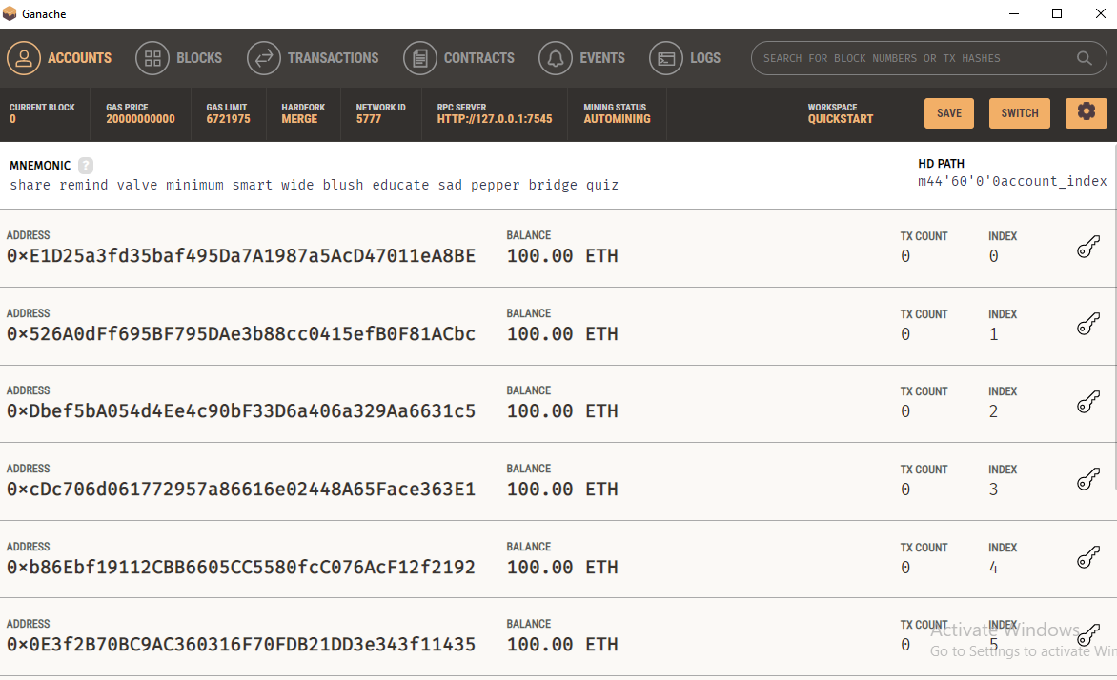

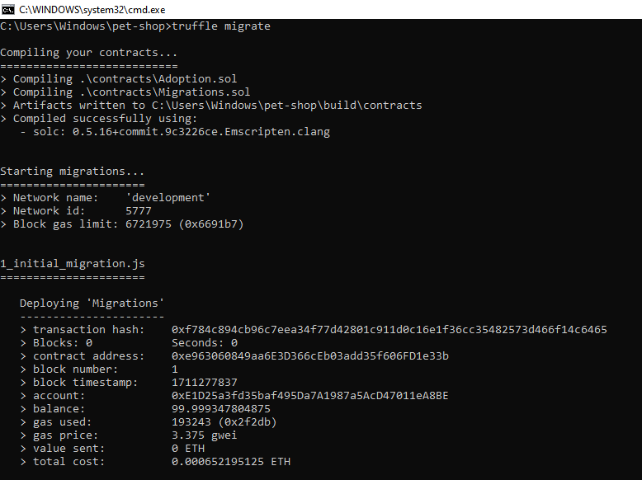

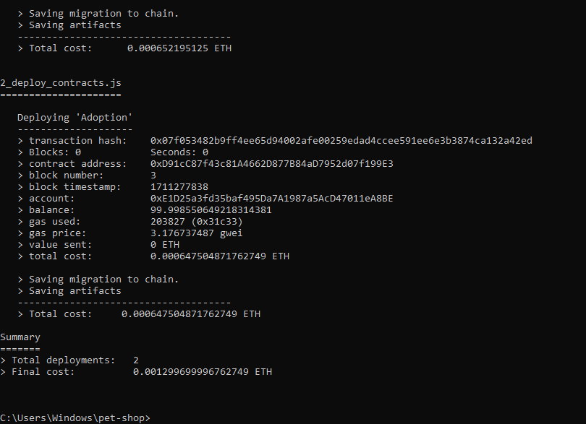

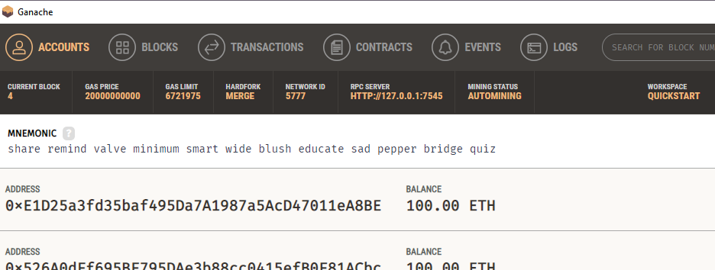

**Test:**

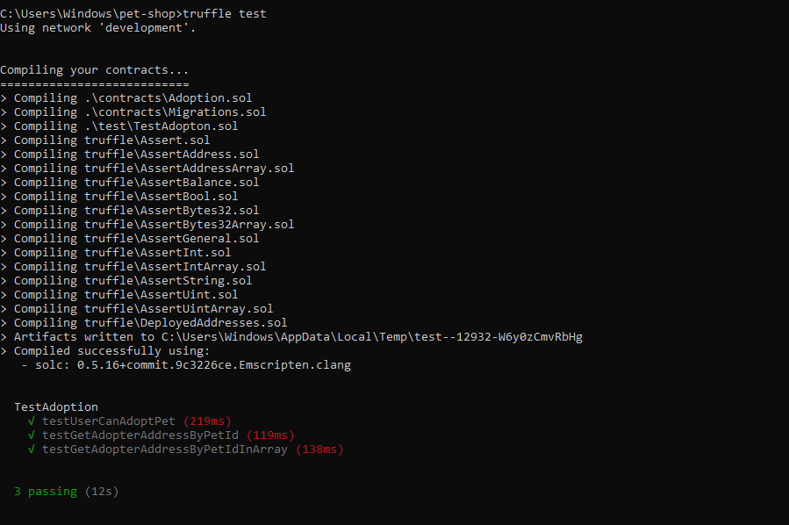

**Task 4:**

I created a user interface to interact with the smart contract according to the code snippets provided as shown below.

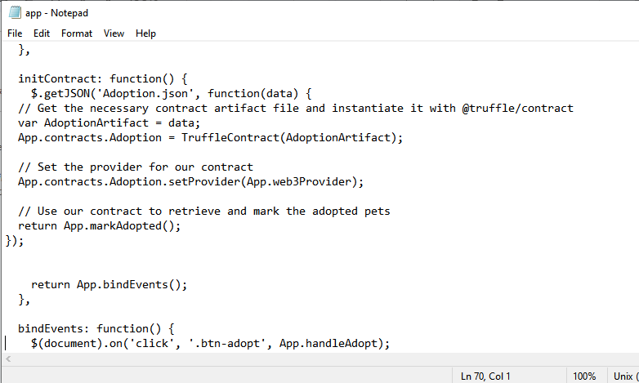

Then I saved the file.

For interacting with DAPP in browser, I **installed and configured** the **MetaMask.**

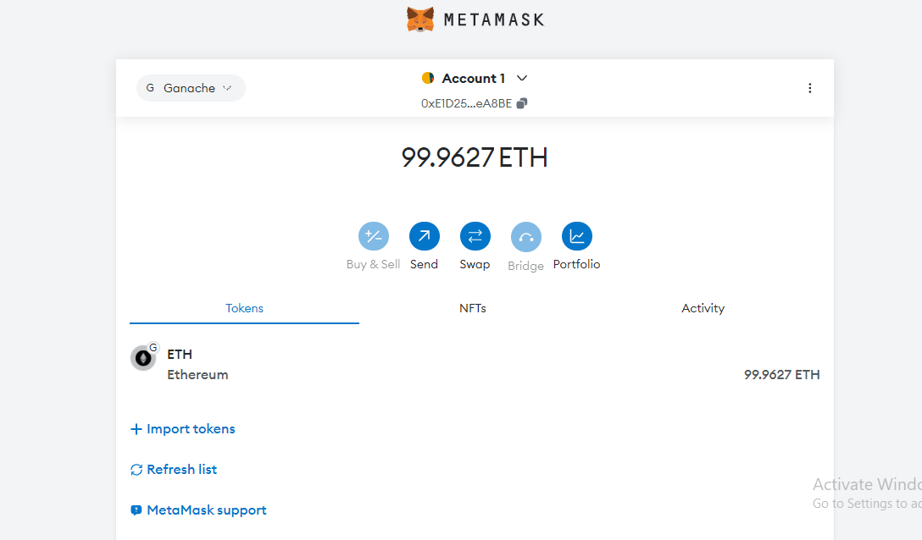

**Installing and configuring lite-server:**

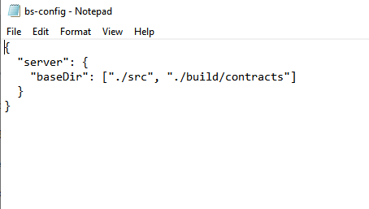

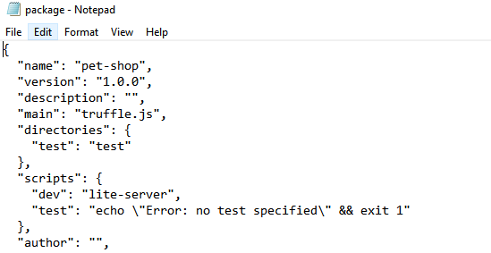

**Using the DAPP:**

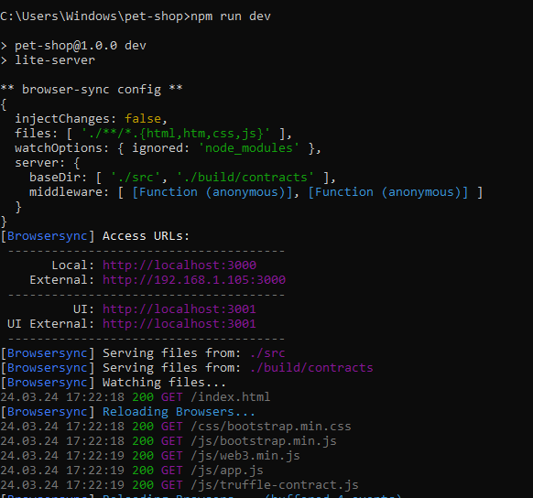

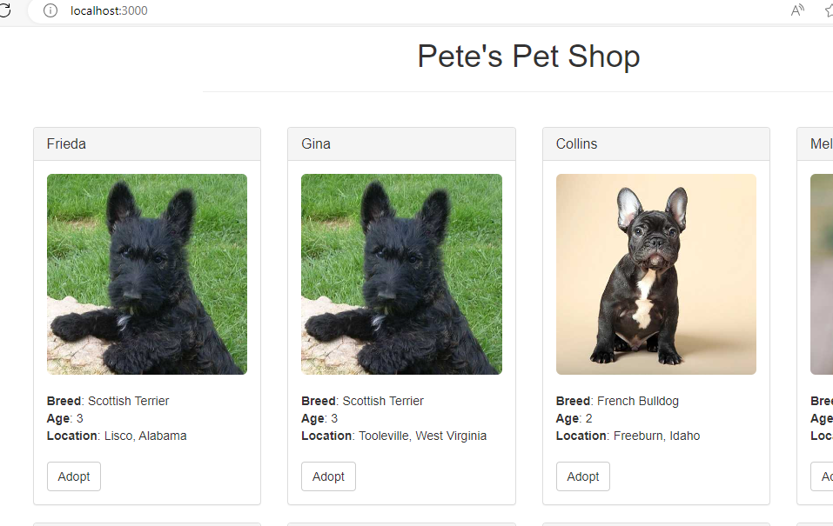

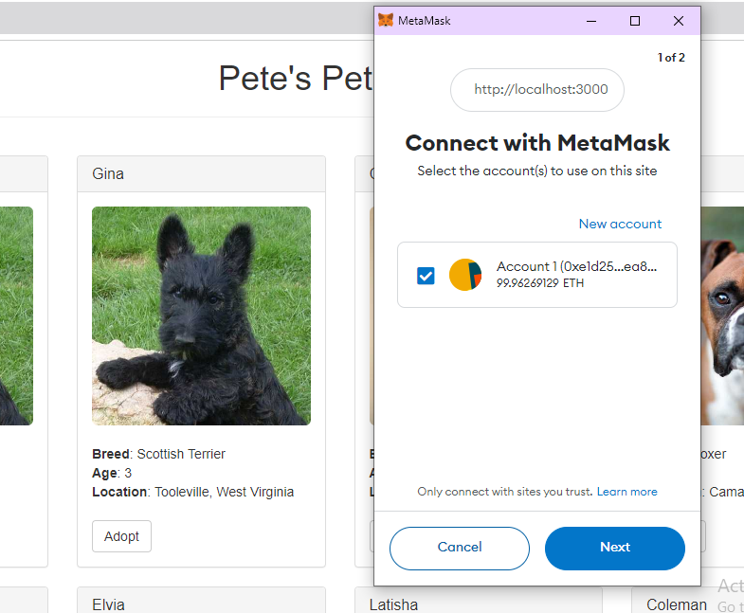

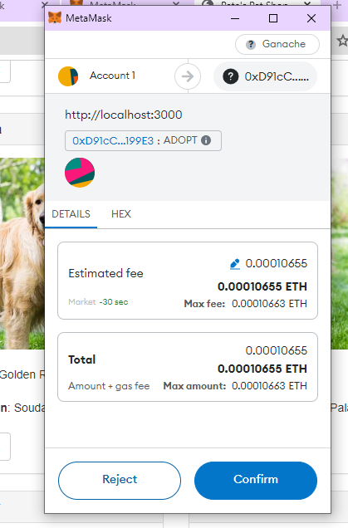

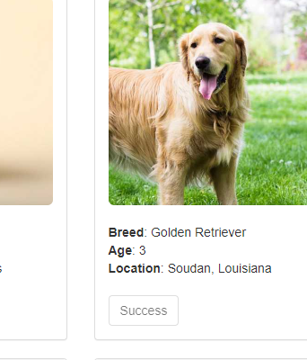

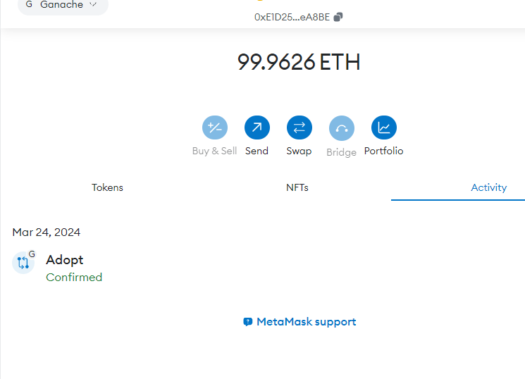

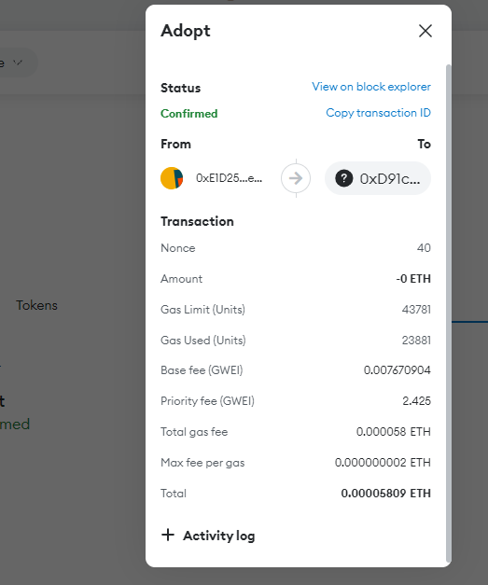

**Link to video:**

https://drive.google.com/file/d/19rAlnsAzmJz0BDLIixXawGAbA5RKcmBf/view?usp=drive_link